CS 157 EXERCISE KEY

Quiz 10
- Write a querry to get details of all the parts supplied by supplier Smith
select shipments.*
from suppliers, SHIPMENTS
where suppliers.sname = 'Smith'and suppliers.SNUM= SHIPMENTS.SNUM;

- Write a querry to get all details of an employee along with his superviser ‘s fname and lname
select e.PRIKEY, e.fname, e.LNAME, e.MINIT, e.ssn, e.ADDRESS, e.BDATE, e.SALARY, e.SEX, s.FNAME, s.LNAME
from employee s, EMPLOYEE e
where s.PRIKEY= e.SUPERPRIKEY;

I. Give the output of the following SQL query using the data &
tables on page 3.

** 1. SELECT EMPLOYEE.SSN, EMPLOYEE.LNAME
FROM DEPARTMENT, EMPLOYEE
WHERE DEPARTMENT.DNAME = 'Administration'
AND EMPLOYEE.DNO = DEPARTMENT.DNUMBER;
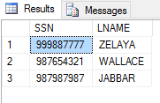

** 2. SELECT EMPLOYEE.FNAME, EMPLOYEE.BDATE
FROM DEPARTMENT, EMPLOYEE
WHERE EMPLOYEE.DNO = DEPARTMENT.DNUMBER
AND DEPARTMENT.DNAME = 'Headquarters';
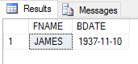

** 3. SELECT EMPLOYEE.FNAME, EMPLOYEE.LNAME
FROM EMPLOYEE
WHERE EXISTS
(SELECT *
FROM WORKS_ON
WHERE WORKS_ON.WSSN = EMPLOYEE.SSN
AND WORKS_ON.PNO <> 1)
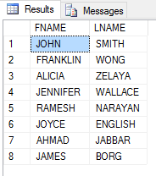

** 4. SELECT EMPLOYEE.SSN, EMPLOYEE.LNAME, EMPLOYEE.BDATE
FROM EMPLOYEE
WHERE EMPLOYEE.ADDRESS LIKE '%Bellaire%';
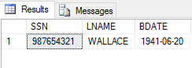

*** 5. SELECT EMPLOYEE.SSN, EMPLOYEE.FNAME, EMPLOYEE.LNAME
FROM EMPLOYEE
WHERE EXISTS (SELECT *
FROM DEPENDENT
WHERE EMPLOYEE.SSN = DEPENDENT.DEPSSN)
AND
EXISTS (SELECT *
FROM DEPARTMENT
WHERE EMPLOYEE.SSN = DEPARTMENT.MGRSSN);
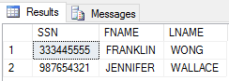

*** 6. SELECT EMPLOYEE.LNAME, EMPLOYEE.FNAME
FROM EMPLOYEE
WHERE (SELECT COUNT(*)
FROM WORKS_ON
WHERE EMPLOYEE.SSN = WORKS_ON.WSSN) >= 2;
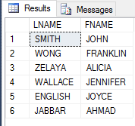

*** 7. SELECT LNAME, SALARY
FROM EMPLOYEE
ORDER BY SALARY DESC, LNAME ASC;

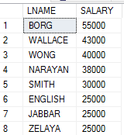

*** 8. SELECT DEPARTMENT.DNAME, COUNT(*)
FROM DEPARTMENT, EMPLOYEE
WHERE DEPARTMENT.DNUMBER = EMPLOYEE.DNO
GROUP BY DEPARTMENT.DNAME
HAVING COUNT(*) > 2
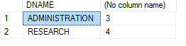

II. Give SQL syntax for the following English descriptions.
Use the data & tables on page 143 of Date's book.

*** 9. Give names of projects which have at least one part supplied by Smith.
(> 1 solutions: in, exist, equal join)

select pname
from project
where dnum in (select dno
from EMPLOYEE
where lname ='Smith');
or
select pname
from project
where exists (select *
from EMPLOYEE
where dnum =dno and lname ='Smith');

*** 10. Give supplier names and total quantity of parts distributed by each supplier. List the names in alphabetic order.

select suppliers.SNAME, sum(shipments.QTY) as Total
from SUPPLIERS, SHIPMENTS
where SHIPMENTS.SNUM= SUPPLIERS.snum
group by SNAME;
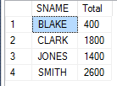

*** 11. Get supplier names who provide parts to a project located in Paris.
(> 1 solutions: in, exist, equal join)

*** 12. Give supplier number for each supplier who provides more than 100 red screws to project #3.
(> 1 solutions: in, exist, equal join)

??????

II. Give SQL syntax for the following English descriptions.
Use the data & tables on page 3.

* 13. Get name of each project located in Stafford.

select p.PNAME
from DEPT_LOCATION d, PROJECT p
where d.DNUMBER = p.DNUM and d.DLOCATION= 'Stafford';
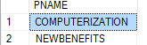

* 14. Get project location of the 'ProductX'.

select p.PLOCATION
from PROJECT p
where P.PNAME= 'PRODUCTX';
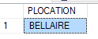

* 15. Get the social security number of each employee who works over 15 hours on at least one project.
select e.ssn
from employee e, works_on w
where w.HOURS>15 and e.ssn=w.WSSN
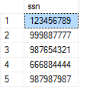

* 16. Get the social security number & last name of each female employee who works in department #4.

select e.ssn, e.LNAME
from employee e
where e.sex= 'F' and e.dno = '4';
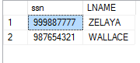

* 17. Increase the salary of each employee working in department #5 by 8.5%.
update employee set salary = (salary * 1.085) where EMPLOYEE.dno='5';
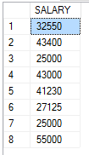

** 18. For each employee, get his/her social security number and total # of hours he/she works.
select e.SSN, sum(w.HOURS) as Sum
from employee e, WORKS_ON w
where PRIKEY=WPRIKEY and w.hours is not null
group by e.ssn;

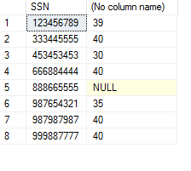

** 19. For each employee, list his/her ssn & number of projects (not project #) that he/she is working on.
(> 1 solutions: in, exists, equal join)
select e.ssn, count(*) as Count
from EMPLOYEE e, WORKS_ON w
where e.ssn=w.wssn
group by e.ssn
having count(*) >0

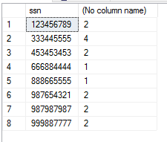

** 20. For each supervisor, retrieve his/her social security number, and the maximun salary among those employees supervised by him/her.
select e1.SUPERSSN, max(e2.salary) as Max
from employee e1, employee e2
where e1.SUPERPRIKEY = e2.SUPERPRIKEY
group by e1.SUPERSSN;

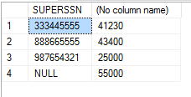

** 21. For each department, get its department # & an average salary of all employee working there.

select DNUMBER, avg(salary) as Average
from department d, employee
where dnumber = dno
group by dnumber;

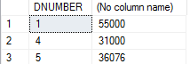

** 22. Get the first & last names of employees who work for 20
hours per week or more on project number less than 15.
(use “in” “exists” join)
select fname, lname
from employee
where ssn in (select essn
from works_on
where pno < 15 and hours >= 20);
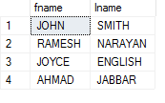
OR
select fname, lname
from employee
where exists (select *
from works_on
where ssn = essn and pno < 15
and hours >= 20);

OR
select fname, lname
from employee, works_on
where ssn = essn and pno < 15 and hours >= 20;
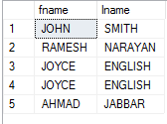

** 23. Get the first & last names of employees who have at
least one son.

select fname, lname
from employee, dependent
where ssn = essn and dependent.relationship = 'son';

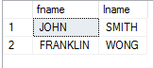
OR select fname, lname
from employee
where ssn in (select essn
from dependent
where relationship = 'son');
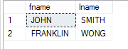

OR select fname, lname
from employee
where exists (select *
from dependent
where ssn = essn
and relationship = 'son');
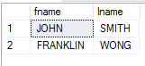

** 24. Get last name of each employee who does not work on
project #1. Assume every employee works on at least
one project.

select lname
from employee
where not exists
(select *
from works_on
where essn = ssn and pno = 1);
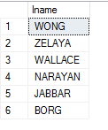

OR
select lname
from employee
where ssn not in (select essn
from works_on
where pno = 1);
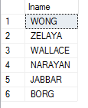

OR
select lname
from employee, works_on
where pno <> 1 and ssn = essn;
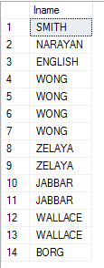

** 25. For each employee, list the first and last name of his/her dependent(s).
(> 1 solutions: in, exists, equal join)

select dependent_name, lname
from employee, dependent
where ssn = essn;
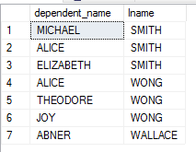

** 26. Get name of each department which has a location in Houston. ( > 1 solutions: exists, in, equal join)

SELECT DEPARTMENT.DNAME
FROM DEPARTMENT, DEPT_LOCATION
WHERE DEPARTMENT.DNUMBER = DEPT_LOCATION.DNUMBER
AND DEPT_LOCATION.DLOCATIO = 'Houston';
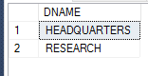

** 27. Get first & last name of the manager in the Research department. ( > 1 solutions: exists, in, equal join)

select fname, lname
from employee, department
where ssn = mgrssn and dname = 'Research';

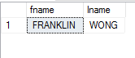

** 28. For each employee, list his/her ssn & names of projects that he/she is working on.
(> 1 solutions: in, exists, equal join)

select essn, pname
from works_on, project
where pno = pnumber;
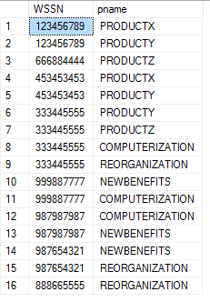
** 29. Get department name of the 'Reorganization' project.
(> 1 solutions: in, exists, equal join)

select dname
from department, project
where dnumber = dnum and pname = 'Reorganization';
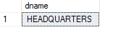

** 30. For the 'Research' department, get its department number & last names of its employees.
(> 1 solutions: in, exists, equal join)

select dno, lname
from department, employee
where dnumber = dno and dname = 'Research';
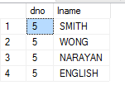

** 31. Get first & last name of each employee who has a dependent with the same first name as the employee.
( > 1 solutions: exists, in, equal join)

select fname, lname
from employee
where ssn in (select depssn
from dependent
where depssn = ssn
and fname = dependent_name);

OR
select fname, lname
from employee, dependent
where ssn = essn and fname = dependent_name;

*** 32. Get department name & the average salary of all employees in each department.

select dname, avg(salary)
from department, employee
where dnumber = dno
group by dname;
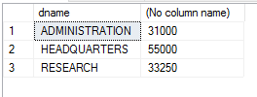

*** 33. Get the first & last names of all employees who work on the 'ProductZ' project over 5 hours per week.
(> 1 solutions: in, exists, equal join)

select fname, lname
from employee, works_on, project
where pname = 'ProductZ' and ssn = essn and
pno = pnumber and hours > 5;
select fname, lname
from employee
where ssn in (select wssn
from works_on
where hours > 5 and pno in (select pnum
where project
pname = “ProfuctZ”))
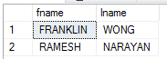

*** 34. Get department # for each department which has average salary more than $30000.

select dno
from employee
group by dno
having avg(salary) > 30000;
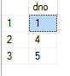

*** 35. Get the first & last names of employees who have at
least one dependent born in 1978.

select distinct fname, lname
from employee, dependent
where ssn = essn and dependent.bdate like '_______78';


*** 36. Get deparment number who has at least one employee working on project number 1 or 2 or 30.

select dno
from employee, works_on
where ssn = essn and pno in (1, 2, 30);
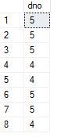
OR
select dno
from employee
where ssn in (select essn
from works_on
where pno in (1, 2, 30));
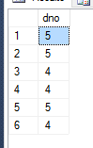
OR
select dno
from employee
where exists (select *
from works_on
where ssn = essn and pno in (1, 2, 30));

OR
select dnum
from project
where pnumber in (select pno
from works_on
where pno in (1, 2, 30));
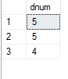

Note: 'pno in (1, 2, 30)' can be replaced by
'pno = 1 or pno = 2 or pno = 30'

*** 37. Get ssn & address of each employee who works with Jennifer Wallace on the same project.

select ssn, address
from works_on, employee
where essn = ssn and pno in
(select pno
from works_on, employee
where essn = ssn and lname = 'Wallace'
and fname = 'Jennifer');
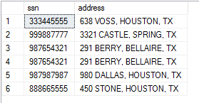
*** 38. Get the social security number of all employees who work on 3 or more projects.

select ssn
from employee
where (select count(*)
from works_on
where ssn = essn) >= 3;
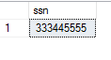
*** 39. Remove John Smith's spouse from the dependent list.

delete
from dependent
where relationship = 'spouse' and
ssn = (select ssn
from employee
where fname = 'John' and lname = ;Smith');

*** 40. Decrease 5 hours per week from each project that Joyce English works on.

update works_on
set hours = hours - 5
where essn = (select ssn
from employee
where fname = 'Joyce'
and lname = 'English');

*** 41. Find social security number and last name of the employee who has the highest salary in his/her department.
(> 1 solutions: exists, =)

select ssn, lname
from employee e1
where salary = (select max(salary)
from employee e2
where e1.dno = e2.dno);

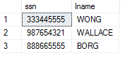

**** 42. Get department name & birthday of each employee who
works in Houston. The list should be ordered by the
department & within each department ordered
chronologically by birthday.

select dname, bdate
from employee, department
where dno = dnumber
order by dname, bdate;
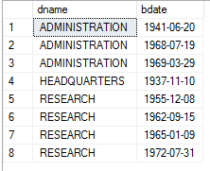

**** 43. Retrieve the first and last names of employees who work in Administration department and are supervised under James Borg.
(> 1 solutions: equal join, in, =, exists)

select fname, lname
from employee
where superssn = (select ssn
from employee
where fname = 'James'
and lname = 'Borg')
and dno = (select dnumber
from department
where dname = 'Administration');
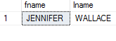
OR
select fname, lname
from employee, department
where dno = dnumber and dname = 'Administration'
and superssn = (select ssn
from employee
where fname = 'James'
and lname = 'Borg');

IV. Give the output of the following relational algebra query
using the data & tables on page 3.

** 44. ((EMPLOYEE WHERE PNO = 5 AND SALARY <= 35000)
UNION
(EMPLOYEE WHERE SEX = MALE)) [LNAME, BDATE]

Smith 09-JAN-55
English 31-JUL-62
Wong 08-DEC-45
Narayan 15-SEP-52
Jabbar 29-MAR-59
Borg 10-NOV-27

*** 45. (((DEPENDENT WHERE RELATIONSHIP = 'SON')
UNION
(DEPENDENT WHERE RELATIONSHIP = 'DAUGHTER'))
JOIN EMPLOYEE) [FNAME, LNAME]

(Find the first & last names of employees who have at least one child.)

Franklin Wong
John Smith

**** 46. (DEPENDENT [ESSN, RELATIONSHIP])
DIVIDEBY
(DEPENDENT WHERE RELATIONSHIP = 'SON' [ESSN])

<==> (DEPENDENT [ESSN, RELATIONSHIP])
DIVIDEBY
(33344555, 123456789)

<==> DAUGHTER
SON
SPOUSE

**** 47. (WORKS_ON [ESSN, PNO])
DIVIDEBY
(WORKS_ON WHERE ESSN = 123456789 [PNO])

<==> (WORKS_ON [ESSN, PNO]) DIVIDEBY (1, 2)

<==> 123456789
453453453

(Get ssn of each employee who works on those projects worked by the employee with ssn 123456789.)

III. Give the relational algebra syntax for the following English
descriptions. Use the data & tables on page 3.
(10 points each)

* 48. Get the social security number & last name of each employee who works in department #5.

(EMPLOYEE WHERE DNO = 5) [SSN, LNAME]

* 49. Get project names which are under development in department #5.

(PROJECT WHERE DNUM = 5) [PNAME]

** 50. Get the social security number & the salary of each employee who works in Houston.
employee join works_on join project
where employee.ssn=works_on.ssn, and
works_on.pno= project.pno and dlocation='houston'
better:
select ssn, salary
from employee, works_on, project, DEPT_LOCATION
where employee.ssn=works_on.wssn and
works_on.pno= project.pnumber and DLOCATION ='Houston';

Wrong
((dept_locations where dlocation = 'Houston')
join employee) [ssn, salary]

** 51. Get the last name & birthday of each employee who works for 30 hours per week or more on project #10.

((works_on where pno = 10 and hours >= 30)
join employee) [lname, birthday]

** 52. Get ssn of employees who are not manager.

(EMPLOYEE [SSN]) MINUS (DEPARTMENT [MGRSSN])

*** 53. For each employee, list his/her ssn & names of projects that he/she is working on.

(WORKS_ON RENAME PNO AS PNUMBER) JOIN PROJECT
[ESSN, PNAME]

*** 54. For the 'Research' department, get its department number & last names of its employees.

(DEPARTMENT RENAME DNUMBER AS DNO
WHERE DNAME = 'Research') JOIN EMPLOYEE
[DNO, LNAME]

*** 55. Get the social security number of each employee who has no dependent.

(EMPLOYEE [SSN])
MINUS
(DEPENDENT RENAME ESSN AS SSN [SSN])

*** 56. Get the first & last names of employees who have at least one children. Assume each child of an employee in this company is a dependent of that employee.

((dependent where relationship = 'son' or relationship = 'daughter')
join employee) [fname, lname]

(If OR is not allowed:)
(((dependent where relationship = 'son')
union (dependent where relationship = 'daughter'))
join employee) [fname, lname]

III. Give the relational calculus syntax for the following
English descriptions. Use the data & tables on page 3.

* 57. Get address & birthday of employee whose name is
'Jennifer S. Wallance'.

RANGE OF EX IS EMPLOYEE
EX.ADDRESS, EX.BDATE WHERE EX.FNAME = 'Jennifer'
AND EX.MINIT = 'S'
AND EX.LNAME = 'Wallance'

* 58. Get manager's last name for the 'Administration' department.

RANGE OF EX IS EMPLOYEE
RANGE OF DX IS DEPARTMENT

EX.LNAME WHERE EXISTS DX
(EX.SSN = DX.MGRSSN AND DX.DNAME = 'Administration')

V. Given the following relation and its functional
dependencies.
(a) Identify its highest normal form, and
(b) give reason that the relation is in this normal form
but not in the next higher normal form.
If the relation is not in BCNF,
(c) find its non-loss decomposition into BCNF, and
(d) identify the candidate key(s) of each relation in your
answer from (c).
You must show your work. (10 points)

* 59. R1(e, f, g, h, i, j)
e -----> j
h -----> i
[e, f, g] is a composite key.

1NF because every attribute is atomic.
not in 2NF because the non-keys j are not fully dependent on the key [e, f, g]. It
depends on a part of the key.

non-loss decomposition:

R1'(e, f, g, h), key = [e, f, g]
R2'(h, i), key = h
R3'(e,j), key=e

* 60 R1(a, b, c, d, e)
a -----> c
b -----> e
c -----> d
[a, b] is a composite key.

1NF because every attribute is atomic.
not in 2NF because the non-keys c, d & e are not fully dependent on the key [a, b]. They
depend on a part of the key.

non-loss decomposition:

R1'(a, b, c, e) key = [a, b]
R2'(c, d) key = c

OR R1" (a, c) key = a
R2" (c, d) key = c
R3" (b, e) key = b

* 61. R1(i, j, k, l)
k -----> i
[i, j] is a composite key.

3NF, because the non-key, l, is directly dependent on the candidate keys, [i, k] & [k, j].
not BCNF because the determinant, k, is not a key.
non-loss decomposition:
R1'(j,k,l) key = [j,k,l]
R2'(k, i) key = k

* 2. R2(p, q, s, t, u)
s -----> t
u -----> q
p is a key.

2NF because all nonkeys (q, s, t, & u) are fully dependent on the key p.
not in 3NF because nonkeys t & q depends on nonkeys s & u respectively.

non-loss decomposition:

R1'(s, t),key = s
R2'(u, q), key = u
R3"(p, s, u), key = p

* 62. R3(w, x, y, z)
[x, z] is a composite key.

BCNF because the only determinant [x, z] is also a key.

* 63. R4(m, n, o, p, q)
m, n are 2 keys, & [o, p] is a composite key.

BCNF because all determinents (m, n & [o, p]) are keys.

* 64. R3(m, n)
m -----> n
n -----> m

BCNF

* 65. R5(a, b, c, d, e, f)
c -----> a
c -----> f
d -----> b
[c, d] is a composite key.

1NF, R1'(c, d, e), key = [c, d];
R2'(c, a, f), key = c;
R3'(d, b). key = d.

* 66. R6(a, b, c, d, e)
[b, c] -----> a
[b, c] -----> d
[b, c] -----> e
d -----> e
a is a key.

2NF, R1'(a, b, c, d), 2 keys = a & [b, c];
R2'(d, e), key = d.

* 67. R2(x, y, z)
z -----> y
x is a key.

2NF, R1'(x, z),key = x; R2'(z, y), key = z.
2) Given the following relation and their functional dependencies. Find the non-loss decompositions into BCNF. Show your work and identify the candidate key(s) of each relation, and the highest normal form of each function. Give the reason that it is not in the next higher normal form.

R(a,b,c,d,e)
e-----> c
[a,c] is a composite key.

Ans:
C.K [a,c] , [a.e]
BCNF since every determinat is key.

